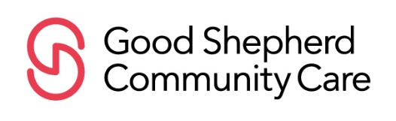

Our Community Resource Library is a space for people to find solace and comfort through the words and voices of others, and to gain access to important resources about death, dying and bereavement.

Dedicate a Book
Proceeds will help fund the many programs of Good Shepherd Community Care. Please contact our Development Associate with questions at (617) 969-6130.

Amount of Donation:
□$1,000 □$500 □$250 □$100 □$50 □$25 □Other
How would you like your donation acknowledged on the bookplate?
- Dedicated by:
- In Honor of:
- In Memory of:
- Anonymous: A Friend of Good Shepherd
Donor Information:  Name: Address:  Phone: Email:_ | Acknowledgement Information: (if applicable)  Please inform the following person of my donation Name: Address:
- Please save a stamp- no acknowledgement necessary to the donor
Please make checks payable to Good Shepherd Community Care
Please charge my: □Visa □ MasterCard □ Discover Credit Card #:
Exp. Date: Sec. Code: Name on Card:
If using your credit card, please make sure to fill out your address, phone number and email.
Or you can donate securely through our website at www.GSCommunityCare.org.

160 Wells Avenue, Newton, MA 02459 ∙ (617) 969-6130 ∙ www.GSCommunityCare.org

